IMPORTING EMPLOYEE-PRODUCER:

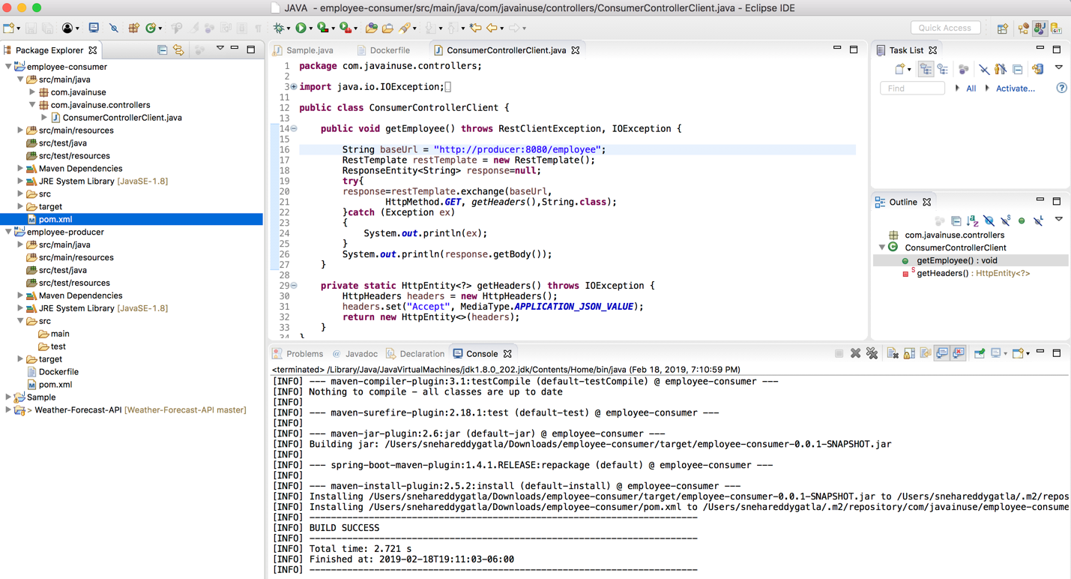

CREATING DOCKER FILE FOR EMPLOYEE-PRODUCER:

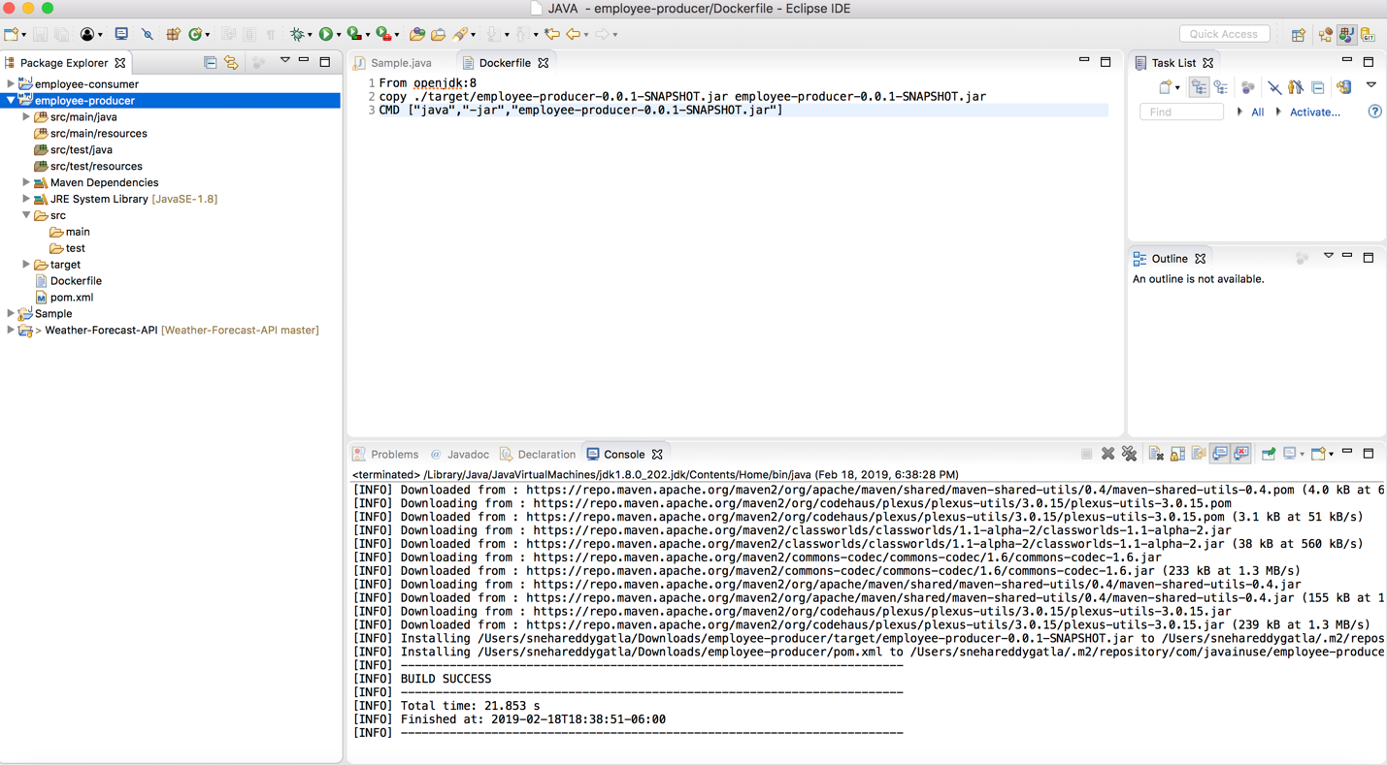

IMPORTING EMPLOYEE-CONSUMER:

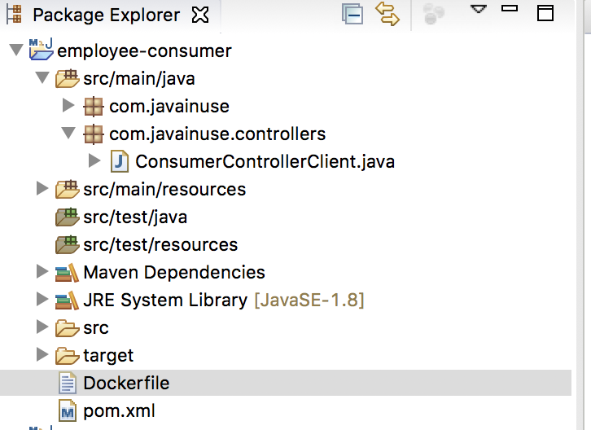

CREATING DOCKER-FILE FOR EMPLOYEE-CONSUMER:

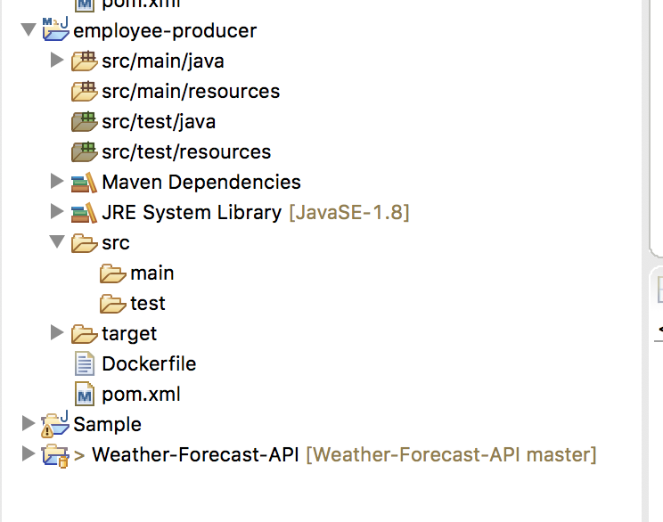

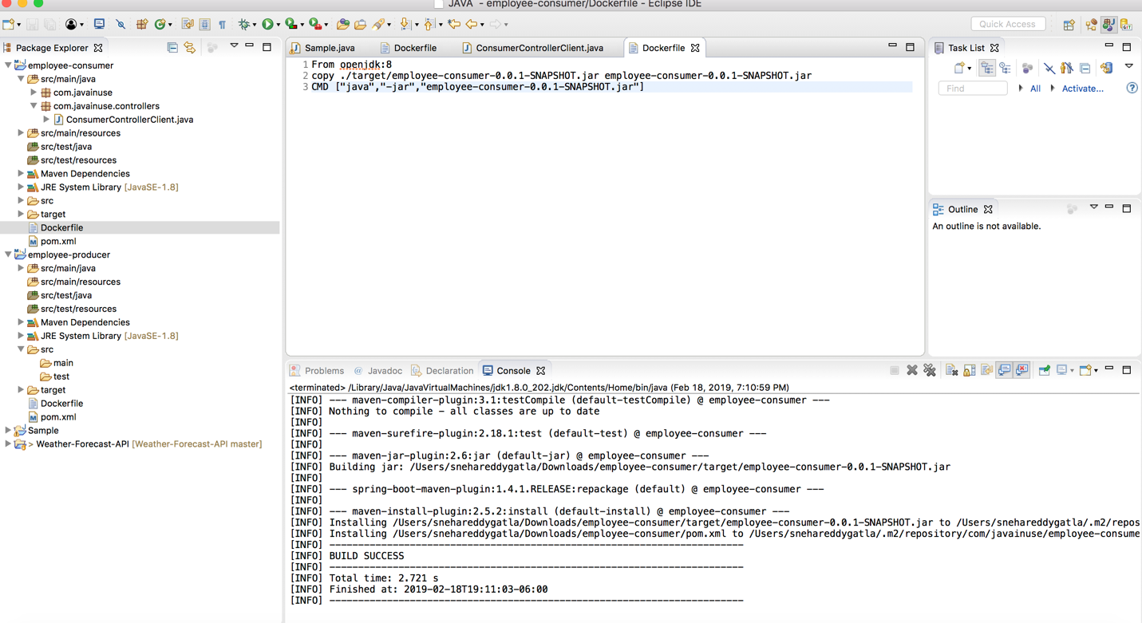

CREATING IMAGE FOR EMPLOYEE-PRODUCER:

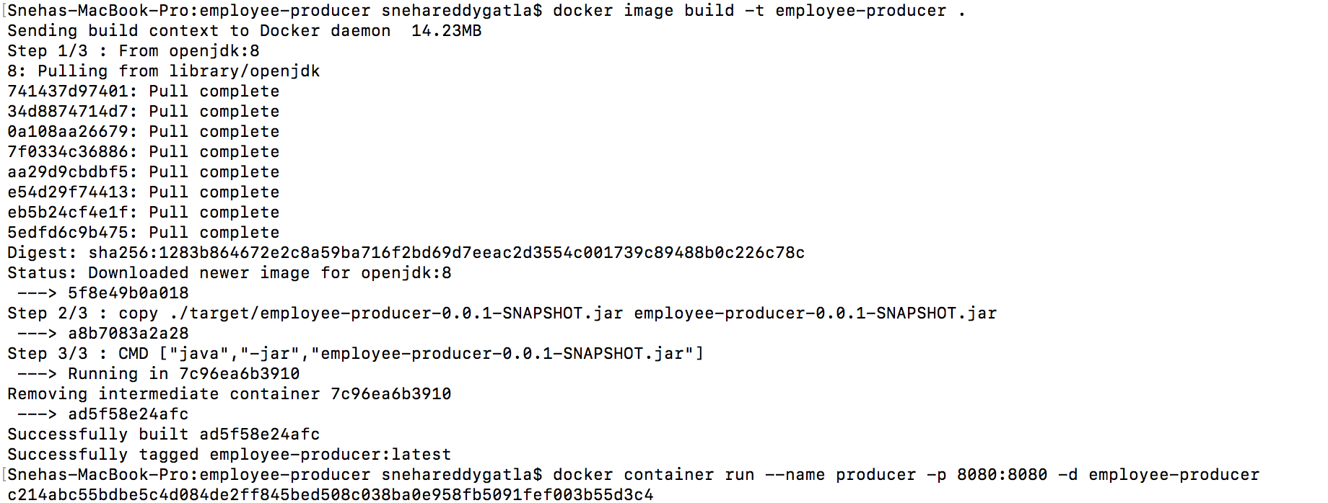

CHECKING LOGS FOR PRODUCER:

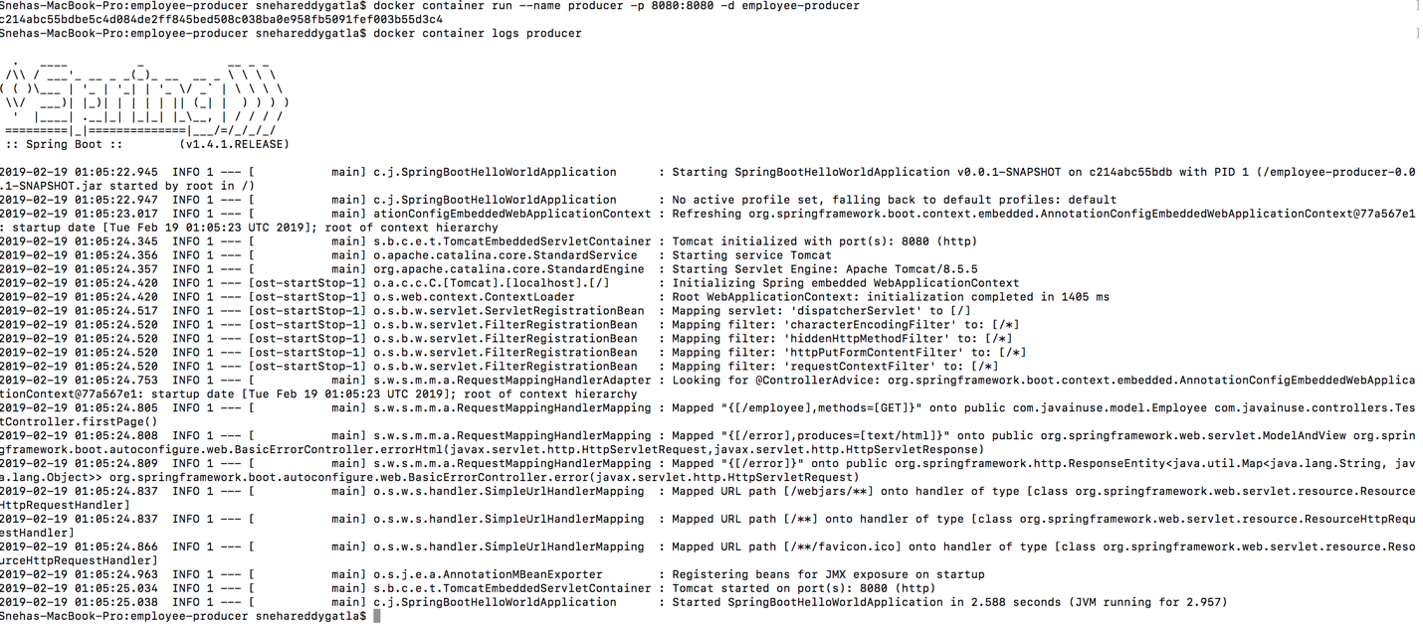

CHECKING ON THE LOCALHOST FOR PRODUCER:

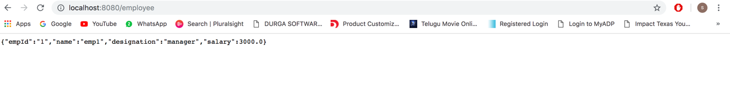

CREATING IMAGE FOR EMPLOYEE-CONSUMER:

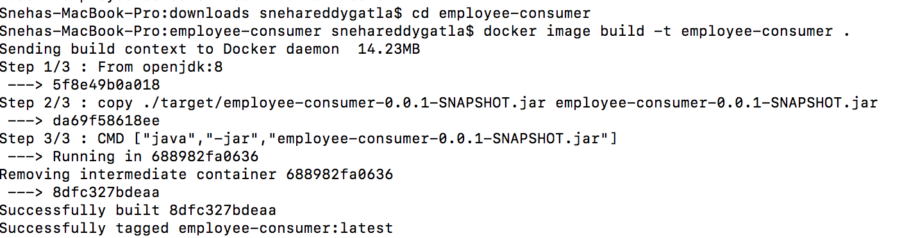

CHECKING LOGS FOR CONSUMER:

Its gets exception after checking the logs because it would not find the path.

So we need to create new one

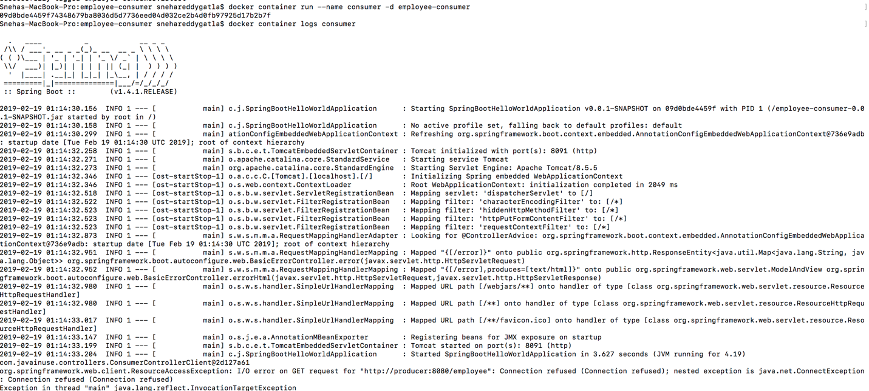

After creating we can check the consumer logs.

The consumer logs are success.

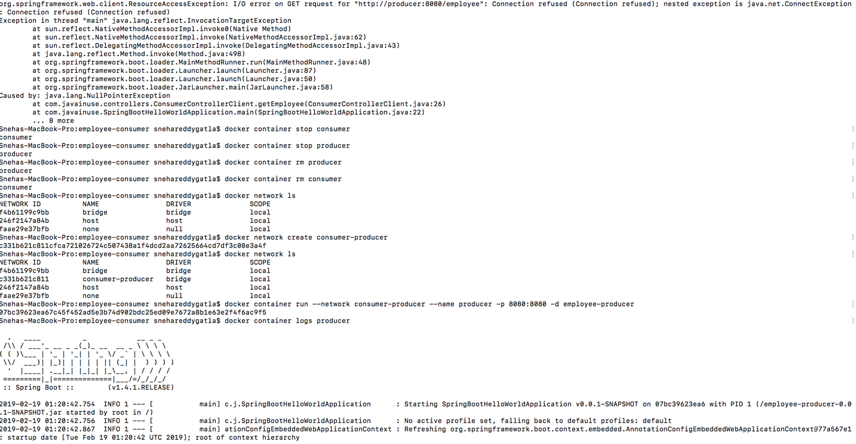

Consumer logs are success as we can see the output below at the last:

